**Lovely Fernandez**

3RD YEAR COMPUTER SCIENCE INTERNATIONAL | TU858-3

More System Analysis  
of Agape’s System

Table of Contents

More System Analysis 1

Use Case 2: Scheduler System 2

Use Case 3: Medicine System 5

Use Case 4: Buddy System 8

Use Case 5: Album System 11

Further Analysis 15

Album System 15

Analysis Class for Album System 18

Schedular System 19

Analysis Class for Scheduler System 22

# More System Analysis

This report consists of 4 use cases which includes a narrative describing the given scenario analysis from Agape’s system, as well as, 2 to 3 exception/alternative flows of each use case.

This report is an extension to Agape or NanAi.

## Use Case 2: Scheduler System

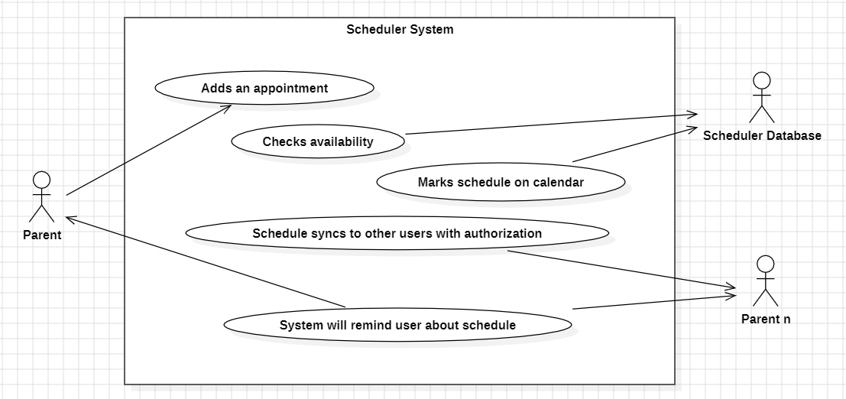

*Figure 1: Use Case Diagram of Scheduler System (StarUML)*

|  |  |  |  |  |
| --- | --- | --- | --- | --- |
| **USE CASE** | | 2 | Using Scheduler System | |
| **Description of Goal in Context** | | User adds an appointment on the app. | | |
| **Preconditions** | | To access scheduler system, a profile for the child must be added. | | |
| **Post Conditions, Success End Condition** | | After using Scheduler System, user has succesfully added an appointment on the calendar. Users connected to the child’s profile will be updated and will have access to this appointment. | | |
| **Post Conditions, Failed End Condition** | | Appointment will not be saved. | | |
| **Actors** | | Parent/Guardian | | |
| **Trigger** | | User clicks add (+) to create a new appointment in scheduler section. | | |
| **DESCRIPTION** | | The user creates an appointment which includes time, place and purpose of the appointment. This will be saved in the system and synced into relevant users. | | |
| **Main Flow (MF)** | | | | |
| **Step** | **Action** | | | **Alternate** |
| 2.1 | User clicks (+) to add an appointment | | |  |
| 2.2 | User inputs appointment details; title, description, time and date. | | |  |
| 2.3 | System will check availability of the given timeslot and date. | | | EF.2.3 |
| 2.4 | User saves the appointment. | | |  |
| 2.5 | System updates its calendar. | | |  |
| 2.6 | System requests user to set the reminder about the appointment. | | |  |
| 2.7 | User will enter the time, date and duration. | | |  |
| 2.8 | System will notify all relevant users of the new appointment and sync to their account calendar including the user’s name of who created the appointment. | | |  |
| 2.9 | On the day of the reminder, system will notify all users about the appointment. | | |  |
| 2.10 | On the day of the appointment, system will notify all users about the appointment in the morning. (6AM) | | |  |
| 2.11 | End use case. | | |  |
| n… | **<…>** | | |  |
|  | | | | |
| **EXCEPTIONS or ERROR Flow Description**  EF.2.3  Error flow at MF.2.3 : Timeslot and date have been booked. | | | | |
| **Step** | **Branching Action** | | | **Alternate** |
| 2.3.1 | System notifies user about existing appointment on the given date and time. | | |  |
| 2.3.2 | User re-schedules to a different time slot or date. | | | AVF.2.3.2 |
| 2.3.3 | Go to MF.2.4 | | | MF.2.4 |
|  | | | | |
| **EXCEPTIONS or ERROR Flow Description**  EF.2.3.2.2  Error flow at AVF.2.3.2.2: User does not re-schedule the existing appointment | | | | |
| **Step** | **Branching Action** | | | **Alternate** |
| 2.3.2.2.1 | User does not override the existing appointment. | | |  |
| 2.3.2.2.2 | User cancels the new appointment | | |  |
| 2.3.2.2.3 | End Use Case 2. | | |  |
|  | | | | |
| **ALTERNATIVE or VARIATION Flow Description**  AVF.2.3.2  Alternative flow at EF.2.3.2: User re-schedules existing appointment. | | | | |
| **Step** | **Branching Action** | | | **Alternate** |
| 2.3.2.1 | System asks user if they would like to override existing appointment. | | |  |
| 2.3.2.2 | User agrees and updates the time slot and date of the existing appointment. | | | EF.2.3.2.2 |
| 2.3.2.3 | Go to EF.1.3.3 | | | EF.2.3.3 |
|  | | | | |

Non-functional Requirements for each use Case can be added in the Table below. Non-functional requirements, management issues and decisions required to be made, can be identified in the following table.

From the table below, **choose a limited number of appropriate non-functional requirements** relevant to the Use Case.

Non Functional Requirements can be categorised as

* Product related
* Organisation related, process and approaches set by the company
* External, imposed by outside bodies

|  |  |  |
| --- | --- | --- |
| **RELATED INFORMATION** | Use Case: 2 | Using Scheduler System |
| **Priority:** | Low Priority, this feature exists to remind users about upcoming events but would still be able to avail Agape’s services even if no appointments are set. | |
| **Product: Performance** | Response time is essential. System should update all relevant parties about the new appointment that has been created. System should sync to cloud’s calendar. | |
| **Product: Efficiency** | Storage is shared via cloud storage. Limited to free storage. | |
| **Product: Reliability** | Shared acorss devices for ease of portability. | |
| **Organisation: Standards** | <company standards for development, documentation etc.> | |
| **Organisation: Delivery** | Electronic notifications on connected devices are set to remind user about upcoming appointments. | |
| **External: Legislation** | <Privacy, data protection, data retention rules, safety etc.> | |
| **External: Ethical** | <appropriate usage: is it appropriate for the target user> | |
| **Frequency** | <how often it is expected to happen> | |
| **Channels to actors** | <e.g. interactive, static files, database, timeouts> | |
| **OPEN ISSUES** | *Manager is respoinsble for deciding on open issues.* | |
| **Due Date** | *Manager is respoinsble for deciding on deadline.* | |
| **…any other management information…** | N/A | |

## Use Case 3: Medicine System

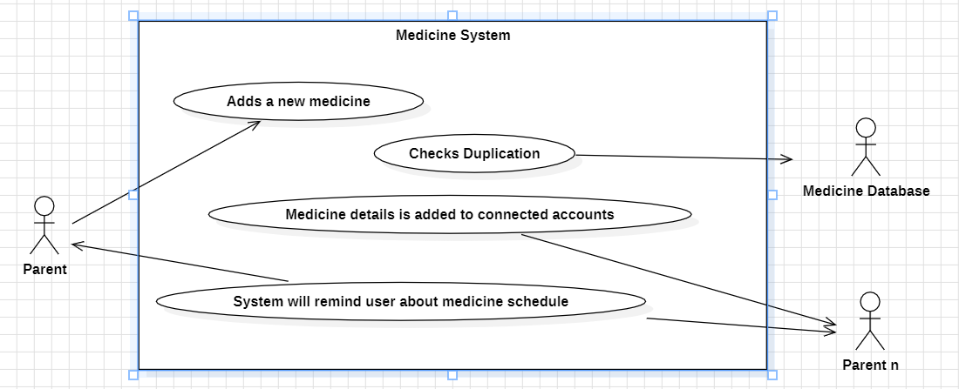

*Figure 2: Use Case Diagram of Medicine System (StarUML)*

|  |  |  |  |  |
| --- | --- | --- | --- | --- |
| **USE CASE** | | 3 | Using Medicine System | |
| **Description of Goal in Context** | | User adds a medicine profile of the medicine into the the child’s profile. | | |
| **Preconditions** | | To access medicine system, a profile for the child must be added. | | |
| **Post Conditions, Success End Condition** | | After using Medicine System, user has succesfully added a medicine profile in the child’s life passbook. Users connected to the child’s profile will be updated and will have access to this information. | | |
| **Post Conditions, Failed End Condition** | | Medicine information will not be saved. | | |
| **Actors** | | Parent/Guardian | | |
| **Trigger** | | User clicks add (+) to create a new medicine profile in Life Passbook. | | |
| **DESCRIPTION** | | The user creates a medicine profile which includes name, description, quantity, and duration. User can add reminders when the medication should be taken and a tracker is created to record if the medication has been taken or not. | | |
| **Main Flow (MF)** | | | | |
| **Step** | **Action** | | | **Alternate** |
| 3.1 | User clicks (+) to add a medicine profile. | | |  |
| 3.2 | User inputs medication details: name, description, quantity and duration. | | |  |
| 3.3 | System will check if medicine profile already exists. | | | EF.3.3 |
| 3.4 | System creates a new profile. | | |  |
| 3.5 | System requests user to set a reminder for the medication. | | |  |
| 3.6 | User inputs time and duration. | | |  |
| 3.7 | System will provide reminders of the medication and notify user at the provided time and date. | | |  |
| 3.8 | User marks medication has been taken. | | | EF.3.8 |
| 3.9 | System updates medication tracker. | | |  |
| 3.10 | End use case. | | |  |
| n… | **<…>** | | |  |
|  | | | | |
| **EXCEPTIONS or ERROR Flow Description**  EF.3.3  Error flow at MF.3.3: Medication already exists. | | | | |
| **Step** | **Branching Action** | | | **Alternate** |
| 3.3.1 | System notifies user about existing medication profile. | | |  |
| 3.3.2 | User opens existing medication profile. | | |  |
| 3.3.3 | User updates existing medication’s quantity and duration. | | |  |
| 3.3.4 | End Use Case 3 | | |  |
|  | | | | |
| **EXCEPTIONS or ERROR Flow Description**  EF.3.8  Error flow at EF.3.8: User re-schedules reminder | | | | |
| **Step** | **Branching Action** | | | **Alternate** |
| 3.8.1 | System alerts user about the medication due | | |  |
| 3.8.2 | User re-schedules the medication time/date. | | |  |
| 3.8.3 | Got MF.3.7 | | | MF.3.7 |

Non-functional Requirements for each use Case can be added in the Table below. Non-functional requirements, management issues and decisions required to be made, can be identified in the following table.

From the table below, **choose a limited number of appropriate non-functional requirements** relevant to the Use Case.

Non Functional Requirements can be categorised as

* Product related
* Organisation related, process and approaches set by the company
* External, imposed by outside bodies

|  |  |  |
| --- | --- | --- |
| **RELATED INFORMATION** | Use Case: 3 | Using Medicine System |
| **Priority:** | Low Priority, this feature exists to remind users about medication intake but would still be able to avail Agape’s services even if no appointments are set. | |
| **Product: Performance** | N/A | |
| **Product: Efficiency** | Storage is shared via cloud storage. Limited to free storage. | |
| **Product: Reliability** | N/A | |
| **Organisation: Standards** | <company standards for development, documentation etc.> | |
| **Organisation: Delivery** | Electronic notifications on connected devices are set to remind user about upcoming medication to be taken. | |
| **External: Legislation** | <Privacy, data protection, data retention rules, safety etc.> | |
| **External: Ethical** | <appropriate usage: is it appropriate for the target user> | |
| **Frequency** | Based on how the user set the medication, may have 2 reminders if medication is to be taken twice a day. | |
| **Channels to actors** | <e.g. interactive, static files, database, timeouts> | |
| **OPEN ISSUES** | *Manager is respoinsble for deciding on open issues.* | |
| **Due Date** | *Manager is respoinsble for deciding on deadline.* | |
| **…any other management information…** | N/A | |

## Use Case 4: Buddy System

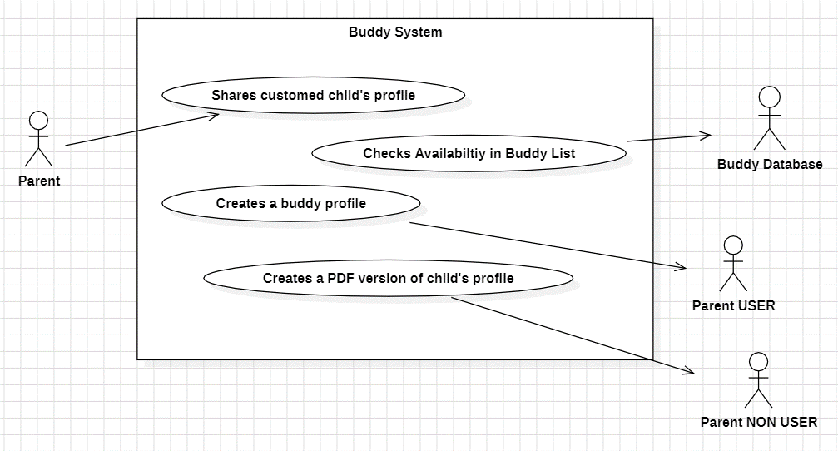

*Figure 3: Use Case Diagram of Buddy System (StarUML)*

|  |  |  |  |  |
| --- | --- | --- | --- | --- |
| **USE CASE** | | 4 | Using Buddy System | |
| **Description of Goal in Context** | | User shares a customed profile of their child to relavent party. | | |
| **Preconditions** | | To access Buddy system, a profile for the child must be added. User should have an existing relationship with the child to share information via Agape directly. | | |
| **Post Conditions, Success End Condition** | | After using Buddy System, user has succesfully shared a customed profile of their child to the relevant party. | | |
| **Post Conditions, Failed End Condition** | | Child’s profile will not be shared. | | |
| **Actors** | | Parent/Guardian | | |
| **Trigger** | | User clicks the share feature on their child’s profile. | | |
| **DESCRIPTION** | | The user shares their child’s customised profile to other parties. User is able to control what information is to be shared. User can share directly with an Agape user or system will allow the option to convert profile into a PDF. | | |
| **Main Flow (MF)** | | | | |
| **Step** | **Action** | | | **Alternate** |
| 4.1 | User clicks share child’s profile. | | |  |
| 4.2 | System will ask what information user would like to share. | | |  |
| 4.3 | User marks which information they would like to share. | | |  |
| 4.4 | System will display the information that will be shared. | | |  |
| 4.5 | User confirms the information. | | |  |
| 4.6 | System asks which user the profile will be shared with. | | | AVF.4.6 |
| 4.7 | User chooses the user which the information will be sent to. | | | EF.4.7 |
| 4.8 | System will prompt the receiving user if they would like to add the profile in their Buddy System. | | |  |
| 4.9 | System sends the information and saves to the receiving user’s account. | | |  |
| 4.10 | System notifies user that the profile has been shared with the chosen user. | | |  |
| 4.11 | End use case. | | |  |
| n… | **<…>** | | |  |
|  | | | | |
| **EXCEPTIONS or ERROR Flow Description**  EF.4.7  Error flow at MF.4.7: Agape User does not have an existing relationship with the child. | | | | |
| **Step** | **Branching Action** | | | **Alternate** |
| 4.3.1 | Users add each other. | | |  |
| 4.3.2 | System creates a relationship of the added user to the child. | | |  |
| 4.3.3 | Go to MF.4.7 | | | MF.4.7 |
|  | | | | |
| **ALTERNATIVE or VARIATION Flow Description**  AVF.4.6  Alternative flow at MF.4.6: User wants to share to a party that is not an Agape User | | | | |
| **Step** | **Branching Action** | | | **Alternate** |
| 4.6.1 | User clicks “Other Option” | | |  |
| 4.6.2 | System requests user to choose what media they would like to send the customed profile | | |  |
| 4.6.3 | User chooses media (SMS/Email/Print/etc.) | | |  |
| 4.6.4 | System converts profile into a PDF | | |  |
| 4.6.5 | User can save or send the PDF directly to the chosen party | | |  |
| 4.6.6 | End Use Case 4 | | |  |
|  | | | | |

Non-functional Requirements for each use Case can be added in the Table below. Non-functional requirements, management issues and decisions required to be made, can be identified in the following table.

From the table below, **choose a limited number of appropriate non-functional requirements** relevant to the Use Case.

Non Functional Requirements can be categorised as

* Product related
* Organisation related, process and approaches set by the company
* External, imposed by outside bodies

|  |  |  |
| --- | --- | --- |
| **RELATED INFORMATION** | Use Case: 4 | Using Buddy System |
| **Priority:** | Mid Priority, User is able to connect with other parties and share a customed profile of their child such as, name, birth-date, allergies, etc. | |
| **Product: Performance** | Response time is essential. Sharing profiles should take less than 2 minutes to connect. | |
| **Product: Efficiency** | Storage is shared via cloud storage. Limited to free storage. | |
| **Product: Reliability** | Profile is able to be converted to PDF if profile is to be shared with a non-user. | |
| **Organisation: Standards** | <company standards for development, documentation etc.> | |
| **Organisation: Delivery** | Important notes such as allergies will be highlighted in the profile provided – prompts are based on level of importance. | |
| **External: Legislation** | <Privacy, data protection, data retention rules, safety etc.> | |
| **External: Ethical** | <appropriate usage: is it appropriate for the target user> | |
| **Frequency** | <how often it is expected to happen> | |
| **Channels to actors** | <e.g. interactive, static files, database, timeouts> | |
| **OPEN ISSUES** | *Manager is respoinsble for deciding on open issues.* | |
| **Due Date** | *Manager is respoinsble for deciding on deadline.* | |
| **…any other management information…** | N/A | |

## Use Case 5: Album System

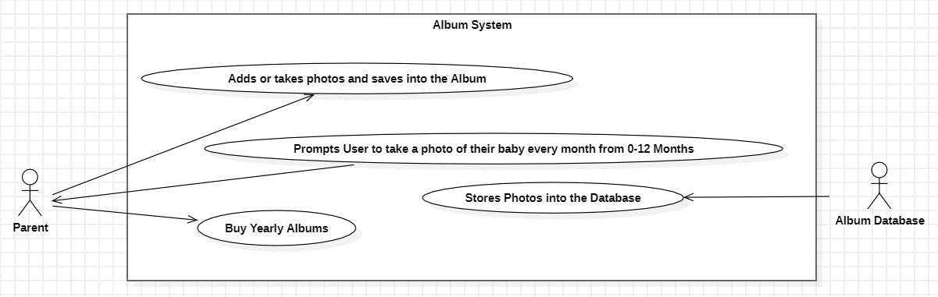

*Figure 4: Use Case Diagram of Album System (StarUML)*

|  |  |  |  |  |
| --- | --- | --- | --- | --- |
| **USE CASE** | | 5 | Using Album System | |
| **Description of Goal in Context** | | User is able to buy a physical album from Agape | | |
| **Preconditions** | | To access Album system, a profile for the child must be added and payment details must be verified. | | |
| **Post Conditions, Success End Condition** | | After using Album System, user has bought an album product from Agape. | | |
| **Post Conditions, Failed End Condition** | | Inability to buy album if payment requirements are invalid. | | |
| **Actors** | | Parent/Guardian | | |
| **Trigger** | | System will prompt a reminder to user, to buy an album or SD card every year of the photos taken/saved in the cloud of that year. User can also directly access this service in Album Feature. | | |
| **DESCRIPTION** | | User can order a physical album to be sent to their home of selected photos from the photo album. User can also opt to add or just buy an SD card for the (unselected) photos. | | |
| **Main Flow (MF)** | | | | |
| **Step** | **Action** | | | **Alternate** |
| 5.1 | User buys a physical album(s). | | |  |
| 5.2 | System requests user to choose photos from the cloud album. | | |  |
| 5.3 | User selects photos to be included. | | |  |
| 5.4 | System asks users what type of album style they would like. | | |  |
| 5.5 | User can choose from the variety of album styles and add a message. | | |  |
| 5.6 | System shows user a sample of how the album will look like. | | |  |
| 5.7 | User confirms the choice of album. | | | EF.5.7 |
| 5.8 | System request for user details: Name, address, email and other information. | | |  |
| 5.9 | User inputs requested information. | | |  |
| 5.10 | System will display total amount for the album. | | |  |
| 5.11 | User provides payment details. | | |  |
| 5.12 | System verifies payment details. | | | EF.5.12 |
| 5.13 | System creates an order for the album. | | |  |
| 5.14 | System sends user an email of reciept. | | |  |
| 5.15 | End use case. | | |  |
| n… | **<…>** | | |  |
|  | | | | |
| **EXCEPTIONS or ERROR Flow Description**  EF.5.7  Error flow at MF.5.7: User is not happy with sample Album | | | | |
| **Step** | **Branching Action** | | | **Alternate** |
| 5.3.1 | System reverts to edit phase | | |  |
| 5.3.2 | User updates their preference in Album style | | |  |
| 5.3.3 | Go to MF.5.6 | | | MF.5.6 |
|  | | | | |
| **EXCEPTIONS or ERROR Flow Description**  EF.5.12  Error flow at EF.5.12: Payment Verification Failed | | | | |
| **Step** | **Branching Action** | | | **Alternate** |
| 5.12.1 | System notifies user that payment verification failed. | | |  |
| 5.12.2 | User updates payment details. | | |  |
| 5.12.3 | Go to MF.5.12 | | | M.5.12 |

Non-functional Requirements for each use Case can be added in the Table below. Non-functional requirements, management issues and decisions required to be made, can be identified in the following table.

From the table below, **choose a limited number of appropriate non-functional requirements** relevant to the Use Case.

Non Functional Requirements can be categorised as

* Product related
* Organisation related, process and approaches set by the company
* External, imposed by outside bodies

|  |  |  |
| --- | --- | --- |
| **RELATED INFORMATION** | Use Case: 5 | Using Album System |
| **Priority:** | Low Priority, this feature is an in-app purchase that provides users to keep a physical copy of the photos on cloud. | |
| **Product: Performance** | Response time is essential. Payment verification should take less than a minute. | |
| **Product: Efficiency** | Storage is shared via cloud storage. Limited to free storage. | |
| **Product: Reliability** | System reminds user about yearly album a week prior to child’s birthday. | |
| **Organisation: Standards** | <company standards for development, documentation etc.> | |
| **Organisation: Delivery** | Physical album/SD Card is to be sent to the provided address of the order. | |
| **External: Legislation** | <Privacy, data protection, data retention rules, safety etc.> | |
| **External: Ethical** | <appropriate usage: is it appropriate for the target user> | |
| **Frequency** | <how often it is expected to happen> | |
| **Channels to actors** | <e.g. interactive, static files, database, timeouts> | |
| **OPEN ISSUES** | *Manager is respoinsble for deciding on open issues.* | |
| **Due Date** | *Manager is respoinsble for deciding on deadline.* | |
| **…any other management information…** | N/A | |

# Further Analysis

Complete a third iteration of use case modelling. Identify two appropriate use case for further analysis.

## Album System

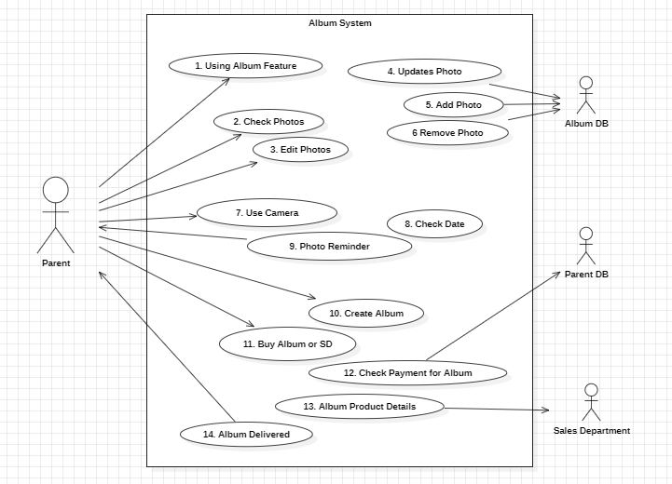

*Figure 5: Use Case Diagram of Album System (StarUML) Further Analysis*

|  |  |  |  |  |
| --- | --- | --- | --- | --- |
| **USE CASE** | | 5 | Using Album System | |
| **Description of Goal in Context** | | The user (parent) wants to capture, organise and store their child’s photos of key moments using the Album System. This feature allows users to create a digital album of their child’s development milestones and have the option to order a physical copy delivered directly to their house. | | |
| **Preconditions** | | To access Album system, a profile for the child must be added and has accessed the Album & Camera feature of the Agape. | | |
| **Post Conditions, Success End Condition** | | Parent has successfully added, organised and updated the photo album of the key moments of their child. An album will be available for purchase including recommended photos or photos personally chosen by the parent. | | |
| **Post Conditions, Failed End Condition** | | The parent experiences errors while attempting to use the Almbun feature dur to technical issues or the app crashes. The parent may also fail to buy an album if payment requirements are invalid. | | |
| **Actors** | | Parent/Guardian | | |
| **Trigger** | | User wants to capture a key moment of their child such as first steps, birthday or a memorable outing. They are able to access the camera of the app which includes various filters or built-in editing tools.  User may also want to upload or download photos into/from the album database. | | |
| **DESCRIPTION** | | The parent is able to document their child’s growth via the Album System. This feature provides tools to capture photos, organise them and add descriptions or notes. The app also includes built-in editing tools to create a customised album. | | |
| **Main Flow (MF)** | | | | |
| **Step** | **Action** | | | **Alternate** |
| 5.1 | User access the Album & Camera feature of the app. | | |  |
| 5.2 | The system displays the main interface of this feature which includes, a photo feed, options to add/upload/download photos as well as creating an album, and a camera option. | | |  |
| 5.3 | The user captures a photo via the camera app. | | | EF.5.3 |
| 5.4 | System provides option to edit photo and add a description. | | |  |
| 5.5 | User writes a decription of the photo. | | |  |
| 5.6 | System adds the photo into the Album Database. | | |  |
| 5.7 | User creates an Album and choses photos to be included. | | | EF.5.7 |
| 5.8 | System saves the album into the parent’s profile to be access for editing or to purchase at a future date. | | |  |
| 5.9 | User decides to buy the album. | | |  |
| 5.10 | System validates payments and delivery destination. | | | EF.5.10 |
| 5.11 | User proivdes delivery information and payments. | | |  |
| 5.12 | System shares the product information to sales department to be readied for delivery. | | |  |
| 5.13 | User recieves the customised Album. | | |  |
| 5.14 | User oragnises photos in specific categories as well as editing photos via the app tools. | | |  |
| 5.15 | System updates changes to photos into the Album Database. | | |  |
| 5.16 | End Use Case 5. | | |  |
| n… | **<…>** | | |  |
|  | | | | |
| **EXCEPTIONS or ERROR Flow Description**  EF.5.3  Error flow at MF.5.7: No Camera Permissions  If the user access the app’s camera to capture a photo without granting camera permissions, the app displays an error message and prompts the user to enable camera access from settings. | | | | |
| **Step** | **Branching Action** | | | **Alternate** |
| 5.3.1 | System prompts an error message requesting for the user to grant camera permission from settings. | | |  |
| 5.3.2 | User allows camera permission from Settings and returns to the app’s Camera. | | |  |
| 5.3.3 | User takes a photo. | | |  |
| 5.3.4 | Go to MF.5.4 | | | MF.5.4 |
|  | | | | |
| **EXCEPTIONS or ERROR Flow Description**  EF.5.10  Error flow at EF.5.12: Payment Verification Failed | | | | |
| **Step** | **Branching Action** | | | **Alternate** |
| 5.10.1 | System notifies user that payment verification failed. | | |  |
| 5.10.2 | User updates payment details. | | |  |
| 5.10.3 | Go to MF.5.10 | | | M.5.10 |

Non-functional Requirements for each use Case can be added in the Table below. Non-functional requirements, management issues and decisions required to be made, can be identified in the following table.

From the table below, **choose a limited number of appropriate non-functional requirements** relevant to the Use Case.

Non Functional Requirements can be categorised as

* Product related
* Organisation related, process and approaches set by the company
* External, imposed by outside bodies

|  |  |  |
| --- | --- | --- |
| **RELATED INFORMATION** | Use Case: 5 | Using Album System |
| **Priority:** | High | |
| **Product: Performance** | Dynamic UI and quick loading time for viewing as well as scrolling through the photo feed. | |
| **Product: Efficiency** | UI must be user-friendly, camera should be accesibile and easy to use. Photos should be organised and be able to share to the top media platforms. | |
| **Product: Reliability** | The album system must be reliable to store and retrieve photos without data loss issues. | |
| **Organisation: Standards** | N/A | |
| **Organisation: Delivery** | Be able to deliver album within 2-3 days business days where 2 weeks as max delay for delivery. | |
| **External: Legislation** | N/A | |
| **External: Ethical** | N/A | |
| **Frequency** | Any time user want to use to Album System, ex. multiple times a week. | |
| **Channels to actors** | Interactive usage such a photo capture, organisation and sharing. | |
| **OPEN ISSUES** | Data backup and synchronization methods to prevent photo loss in case of app crashes or technical issues. | |
| **Due Date** | Second half | |
| **…any other management information…** | N/A | |

### Analysis Class for Album System

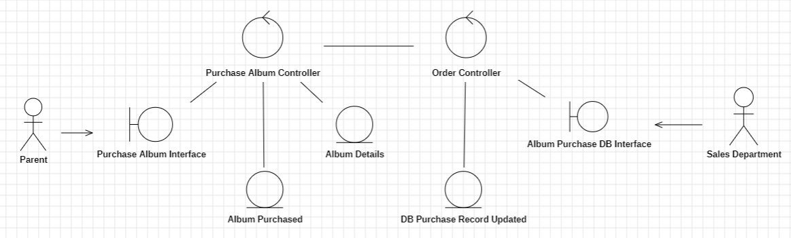  
*Figure 6: Analysis Class for Album System*

## Schedular System

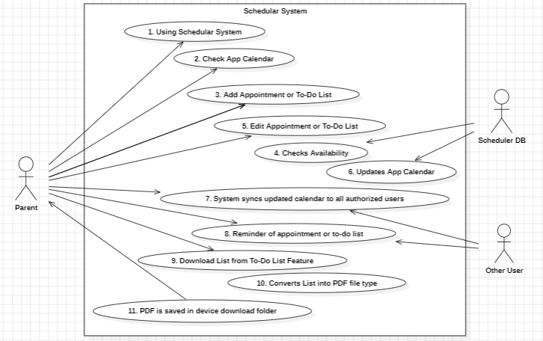

*Figure 1: Use Case Diagram of Scheduler System (StarUML) Further Analysis*

|  |  |  |  |  |
| --- | --- | --- | --- | --- |
| **USE CASE** | | 2 | Using Scheduler System | |
| **Description of Goal in Context** | | The parent is able to manage their parenting-related activities via the Scheduler System. This feature includes scheduling appointments, setting reminders and creating a to-do list which are all saved unto the system’s calendar and synced with other authorized users. | | |
| **Preconditions** | | To access scheduler system, a profile for the child must be added and user accessed the Scheduler System. | | |
| **Post Conditions, Success End Condition** | | User has succesfully adds an appointment on the calendar and other users connected to the child’s profile will be updated and have access to this appointment.  At the set date, the system will remind all related users about the upcoming appointments. | | |
| **Post Conditions, Failed End Condition** | | Unable to save appointment due to technical or network issues. | | |
| **Actors** | | Parent/Guardian | | |
| **Trigger** | | User has an appointment to add or a reminder is set off for a upcoming schedule. | | |
| **DESCRIPTION** | | The user creates an appointment which includes scheduling appointments, setting reminders, and creating and managing to-do lists. This will be saved in the system and synced into relevant users. | | |
| **Main Flow (MF)** | | | | |
| **Step** | **Action** | | | **Alternate** |
| 2.1 | User access the Scheduler System. | | |  |
| 2.2 | System displays a calendar UI which includes options to add a new appointment and the to-do list management. | | |  |
| 2.3 | User adds an appointment. | | |  |
| 2.4 | System request the date, time and a brief description of the appointment. | | |  |
| 2.5 | User adds the appointment information. | | |  |
| 2.6 | System checks availabilty on the calendar. | | | EF.2.6 |
| 2.7 | System updates the new appointment on the app Calendar and syncs to other authorized users’ calendar. | | |  |
| 2.8 | User is able to check upcoming events on the calendar. | | |  |
| 2.9 | User access the to-do list for groceries and adds a new item on the list. | | |  |
| 2.10 | User saves the list on their phone. | | |  |
| 2.11 | System converts the list into a PDF and saves unto the user’s device’s download folder. | | |  |
| 2.12 | End of Use Case 2 | | |  |
| n… | **<…>** | | |  |
|  | | | | |
| **EXCEPTIONS or ERROR Flow Description**  EF.2.6  Error flow at MF.2.6 : Timeslot and date have been booked. | | | | |
| **Step** | **Branching Action** | | | **Alternate** |
| 2.6.1 | System notifies user about existing appointment on the given date and time. | | |  |
| 2.6.2 | User re-schedules to a different time slot or date. | | | AVF.2.6.2 |
| 2.6.3 | Go to MF.2.7 | | | MF.2.7 |
|  | | | | |
| **ALTERNATIVE or VARIATION Flow Description**  AVF.2.6.2  Alternative flow at EF.2.3.2: User re-schedules existing appointment. | | | | |
| **Step** | **Branching Action** | | | **Alternate** |
| 2.6.2.1 | System asks user if they would like to override existing appointment. | | |  |
| 2.6.2.2 | User agrees and updates the time slot and date of the existing appointment. | | |  |
| 2.6.3 | Go to MF.2.7 | | | MF.2.7 |
|  | | | | |

Non-functional Requirements for each use Case can be added in the Table below. Non-functional requirements, management issues and decisions required to be made, can be identified in the following table.

From the table below, **choose a limited number of appropriate non-functional requirements** relevant to the Use Case.

Non Functional Requirements can be categorised as

* Product related
* Organisation related, process and approaches set by the company
* External, imposed by outside bodies

|  |  |  |
| --- | --- | --- |
| **RELATED INFORMATION** | Use Case: 2 | Using Scheduler System |
| **Priority:** | High | |
| **Product: Performance** | <NA> | |
| **Product: Efficiency** | The interface should be user-friendly. Add, edit and delete should be easy to use. | |
| **Product: Reliability** | Reminders must prompt on the set date without delay. Appointment data must be secured. Operation/process must always be stable. | |
| **Organisation: Standards** | <NA> | |
| **Organisation: Delivery** | Electronic notifications on connected devices are set to remind user about upcoming appointments. | |
| **External: Legislation** | <NA> | |
| **External: Ethical** | <NA> | |
| **Frequency** | User may interact with this feature multiple times a day. | |
| **Channels to actors** | Real-time data updates. | |
| **OPEN ISSUES** | Data synchronisation methods to ensure consistency across multiple devices and authorized users. | |
| **Due Date** | Second half | |
| **…any other management information…** | N/A | |

### Analysis Class for Scheduler System

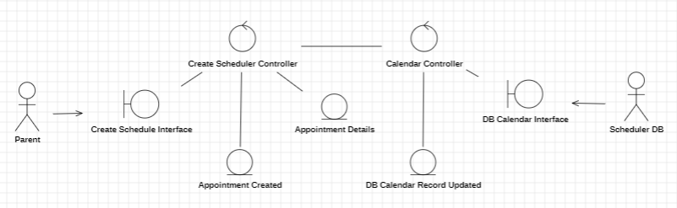

*Figure 7: Analysis Class for Scheduler System*

# Sequence Diagram

Using the analysis classes, from week 5, create one communication/collaboration diagram, in the form of a sequence diagram, to analyse the main flows for the 2 use cases under consideration.

Then identify the design classes from the analysis classes. Draw a sequence diagram based on the design classes.

## Improper Sequence Diagram

*Figure 8: Improper Sequence Diagram of Album and Scheduler Use Cases*

## Design Classes

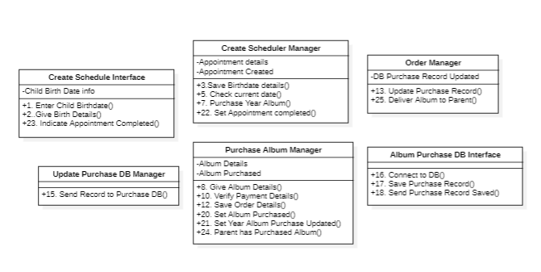

*Figure 9: Design Classes of Album and Scheduler Use Cases*

## Proper Sequence Diagram

*Figure 10: Proper Sequence Diagram of Album and Scheduler Use Cases*